**Consultancy for GALIBBI & BIODEV2030 projects set-up**

**Terms of reference**

1. **Context**

The Guyana Shield is a biodiversity hotspot of regional and global importance. Besides having the most intact rainforest on the planet, the seas of the Guianas are incredibly rich in marine life. Indeed, Guiana's waters are home to many emblematic species, including significant estuarine dolphin populations, manta rays, whales, and five species of endangered marine turtles. The limited number of sandy beaches along the Guianas coastline are of global significance as sea turtle nesting sites. The richness of Guyana's marine ecosystem is also reflected in its considerable fishing potential. The fishery sector serves as an important economic sector for the Guianas and of course sea fish is on the menu of many people, providing an important protein source for many. Therefore, a healthy Guianas ocean is indispensable for the livelihoods of coastal communities.

For large marine vertebrates, and sea turtles in particular, the biggest threat at sea is accidental capture by fishing gear, i.e. the animals are caught by accident and either drown in the net or die after being released. In French Guyana, WWF France has led projects that aim to test fishing gears that can reduce accidental captures, and aims at valorizing those techniques on local markets.

Given its relatively well-preserved resources and the low intensity of its fishing activities, illegal foreign fishing in French Guiana represents the main pressure on part of French territorial waters. According to an Ifremer report, foreign illegal fishing efforts represented two to three times the local fishing effort in 2012 (an update is in progress). These exogenous vessels fish with drift gillnets and are not subject to European Union fisheries management rules. Their illegal fishing takes place mainly in western French Guiana, where the leatherback turtle's major historic egg-laying sites are located. Although substantial resources have been invested in the fight against illegal fishing in French Guiana, it has to be said that the number of vessels and the number of kilometers of illegal nets involved remain significant, particularly in the estuary of the Maroni border river. In 2021 and 2022, WWF's Guiana office carried out aerial surveys showing a very high concentration of foreign vessels fishing illegally in French territorial waters. At the same time, 97% of the leatherback turtle population laying eggs in western Guiana and 60% of the Guiana dolphin population have disappeared in twenty years.

For several years, one of the driving forces behind illegal fishing has been the development of informal trade in sciaenidae swim bladders (acoupas), destined for the Asian market. This organ is sold for up to 30 to 40 times more than the price of fish, at around €150/kg in French Guiana in dried form, while it fetches up to $8,500/kg on Hong Kong markets. This market organizes a parallel economy, and it is feared that if it continues to develop informally, it will threaten fishery resources. The analysis and formalization of this market is therefore imperative, particularly with a view to improving traceability and control to combat the economic engine of illegal fishing.

The mobilization of civil society appears to be a strategic lever for curbing the phenomenon of illegal fishing, and for protecting sea turtle populations more effectively. The need for better local representation of Guyanese active in the conservation sector is essential to mobilize the various publics more widely. With this in mind, and considering the potential of youth as a vector for behavioral change, the emergence of conservation leaders around the unifying theme of marine turtles offers the potential to mobilize the whole of Guyanese society. Last but not least, the implementation of pilot socio-economic projects based on sea turtle protection will demonstrate the potential for development and social inclusion offered by biodiversity.

1. **Objectives**

In this context, WWF French Guyana is recruiting a consultant to administratively and operationally set up two regional projects in the Guianas that will be piloted by the French Guyana office of WWF France :

* GALIBBI (Guianas Acting to Limit IUU Fishing and Boost Blue Initiatives) : Financed by French Agency for Development (AFD) as part of its civil society initiatives program, this project aims at reducing the pressure of illegal fishing in the Maroni estuary (Surinamese and French waters). It will be structured around two specific objectives:
  1. Reduce IUU fishing by strengthening Suriname's capacity to combat it, strengthening bilateral cooperation and addressing its root cause by analyzing the swim bladders market.
  2. Local civil society raises awareness on marine turtle conservation issues, by creating a regional network of young marine biodiversity ambassadors and highlighting successful development biodiversity-based projects.
* [BIODEV2030](https://www.biodev2030.org/) : Implemented in sixteen pilot countries including Guyana, BIODEV2030 is an experimental approach that aims to integrate biodiversity into identified economic sectors of those countries by involving all the players in society. The project’s partners are French Agency for Development (AFD) (funding), Expertise France (coordination), International Union for Conservation of Nature (IUCN) (implementation) and WWF (implementation). After a phase of identification of those sectors, now comes an implementation phase. The first phase of the project (2019-2022) aimed at identifying target sectors as well as defining action plans to reduce their impact on biodiversity. For this second phase, we propose to widen the geographical scope of action, thus covering both Suriname and Guyana, and to focus on the fishery sector, identified as having a strategic impact on development and on biodiversity in the countries.

The aim of this 3-month preparatory consultancy will be to ensure the operational and administrative set-up of both projects in order to start the implementation phase in early 2024.

1. **Modalities and deliverables**

The consultancy aims at setting up the initial preparatory phases of the two projects. The expected duration of the consultancy is three months.

The consultant will report to the French Guyana office of WWF France and will be based in Cayenne, with frequent travels expected to Suriname and Guyana. The consultancy will involve coordination with the identified partners of the two projects to prepare all administrative and operational documents needed to launch the project.

Deliverables :

1. GALIBBI : Compilation of a file (AFD’s NIONG) containing all information required to set up the project, including legal and administrative documents, project content writing, clear definition of the logical framework, budget details, timeline and framing of the various partners.
2. BIODEV2030 :
   1. Summary note on opportunities to work with the public and private players towards more sustainability in the fisheries sector of Guyana and Suriname.
   2. Development of a roadmap for the implementation of sustainable fisheries projects (e.g. bycatch reduction initiatives, no-fishing zones throughout the Guiana Shield, market-based incentives) in coordination with regional partners.
   3. Compilation of all legal and administrative documents necessary to launch the project, including legal and administrative documents, project content writing, clear definition of the logical framework, budget details, timeline and framing of the various partners.
3. **Calendar**

The expected duration of the consultancy is three months, with a starting date **on 22 November 2023**.

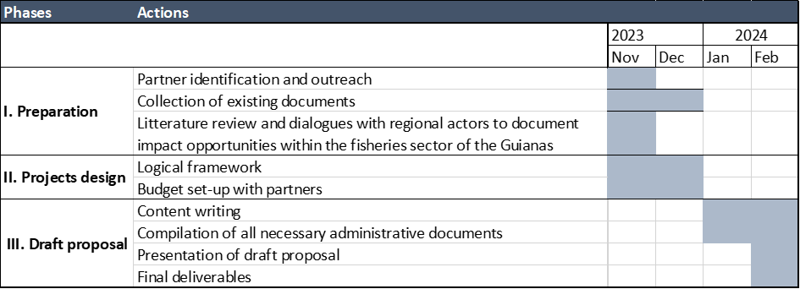

Weekly check-in points will be organized with the French Guyana team.

A presentation of the deliverables to the Public Sector team of WWF France, the French Guyana office, as well as WWF Guianas will be organized on 15 February 2024.

Both project implementations will then aim to start in early 2024.

1. **Process and selection criteria**

From the release date of the Terms of Reference, consultancy candidates will have **until 8 November 2023** to submit an offer, which must include the following elements:

* Presentation of the consultant / team of consultants
* Description of professional references of similar experience
* Presentation of the strategy and proposed solutions
* Project schedule and implementation
* Estimated budget

Proposals will then be evaluated by WWF France according to the criteria and associated weights detailed below:

| **Selection criteria** | **Weighting** |
| --- | --- |
| **Comprehension of the project** |  |
| Appreciation of objectives and challenges | 5% |
| Comprehension and analysis of deliverables | 5% |
| **Presentation of offer** |  |
| Quality of proposed methodology | 10% |
| Compliance of proposal with requirements | 20% |
| **Profile** |  |
| Skills of consultant/team | 15% |
| Professional references | 15% |
| **Price** | 30% |
| **Total** | 100% |

The selected candidate will be announced **by 15 November**. The contract will then start **on 22 November**.